Calculus Lifesaver PDF

Adrian Banner

Q&A

Answers

Contents

Chapter 1 – Functions, Graphs, Lines 1

Chapter 2 – Review of Trigonometry 15

Chapter 3 – Introduction to Limits 15

Chapter 4 – How To Solve Limit Problems Involving Polynomials 15

Chapter 5 – Continuity and Differentiability 15

Chapter 6 – How To Solve Differentiation Problems 15

Chapter 7 – Trig Limits and Derivatives 16

Chapter 8 – Implicit Differentiation and Related Rates 16

Chapter 9 – Exponentials and Logarithms 16

Chapter 10 – Inverse Functions and Inverse Trig Functions 16

Chapter 11 – The Derivative and Graphs 16

Chapter 12 – Sketching Graphs 16

Chapter 13 – Optimisation and Linearisation 17

Chapter 14 – L’Hopital’s Rule and Overview of Limits 17

# Chapter 1 – Functions, Graphs, Lines

1.1

A function is a rule for transforming an object into another object.

1.2

The domain is the set from which the input of a function is drawn. The ‘co-domain’ is the set from which the output of a function is drawn.

1.3

R is the set of real numbers.

1.4

This is called ‘restricting the domain of function f’.

1.5

Only one unique output (per valid input).

1.6

The range of a function is the set of all outputs that could possibly occur. So why isn’t range the same as the codomain? The codomain is the set of possible outputs, whereas the range is the set of actual outputs. So the range is a subset of the codomain.

1.7

A common codomain is R.

1.8

 means the set of all numbers between a & b, including both a and b.

i.e. 

i.e. including fractions, not just integers.

1.9

 means the set of all numbers between a & b but Excluding a and b.

1.10

Closed means  ie. Include the 2 numbers at the end.

Open interval means i.e. don’t include the 2 numbers.

1.11

Half-open interval. i.e. open on one side, closed on the other.

1.12

Interval notation for all numbers greater than or equal to a: 

1.13

Interval notation for all numbers greater than a (but not equal to a): 

1.14

3rd root, 5th root etc.

But can’t get the square root or 4th or 6th root etc.

1.15

Can’t get the log of a negative number or of zero.

1.16

Tan(90deg) is problematic because sin(90deg) / cos(90deg)

= 1/0

And you can’t divide by zero.

1.17

If restrict the domain of a function, technically it is not the same function any more. Even though the calculation steps are identical.

1.18

If change the domain, strictly speaking the name of the function should change. But often mathematicians will just leave the function name unchanged (e.g. ‘f()’ or ‘g()’ or whatever)

1.19

means the interval from -8 to +13 but excluding -8, and also excluding +2.

1.20

If an input ‘x’ has more than 1 possible output ‘y’, then it’s not a function. Should be only 1 unique output ‘y’ for each input. We check this using the VERTICAL LINE TEST. i.e. if you can draw a vertical line anywhere on the graph, and it hits more than one point, then you know it’s not a function.

1.21

No this does not represent a function because it’s possible to draw a vertical line and hit 2 points.

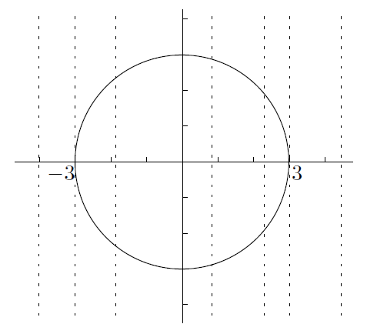

1.22

If the equation for a circle is x2 + y2 = 9, convert this into a function by splitting into 2 separate functions (e.g. one function for the semi-circle on top, another function for the semi-circle on the bottom).

Could also break it into something unusual like this because it doesn’t violate the vertical line test:

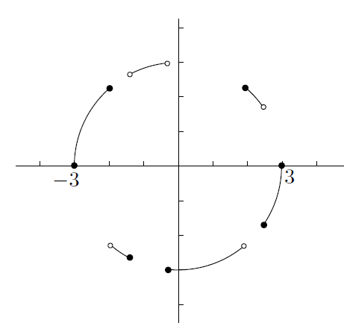

1.23

An inverse function exists if there’s only 1 value of x that satisfies **f(x) = y** , for each output value of y in the range.

1.24

We can use a graph to check if an inverse function exists, using the ‘horizontal line test’. i.e. for a particular value of ‘y’ is there more than one input value of ‘x’ that generates this output. If there is more than one ‘x’, an inverse function does not exist.

1.25

The inverse function is a mirror image of the original function on a graph. You draw the line y=x on the graph (i.e. 45 degrees line). And then you create a mirror image around this diagonal line.

1.26

This graph shows an inverse function. The mirror / reflection is drawn relative to the 45 degree line y=x.

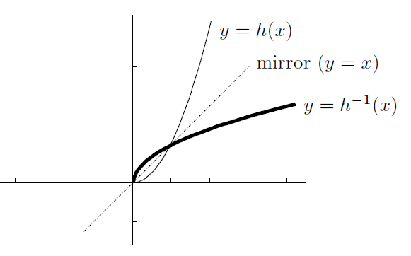

1.27

The connection between the vertical and horizontal line tests is that when a mirror reflection is created, a vertical line becomes a horizontal line, and vice versa.

1.28

 the circle means composed with. Composition of functions. So first do function g(). And then the result is fed into function h().

1.29

No, composition of functions is not the same as multiplication. You don’t multiply them by each other. You simply feed the result of one into the other.

1.30

This means that f() is composed of 4 different functions. Starting with g(), then n() etc.



1.31

No, f(x) is not the composition of 2 functions here. Because x is in the 2 function twice. So you can’t decompose into separate functions. Need to use the same input for both parts.



1.32

To sketch the function f(x) = (x-1)2

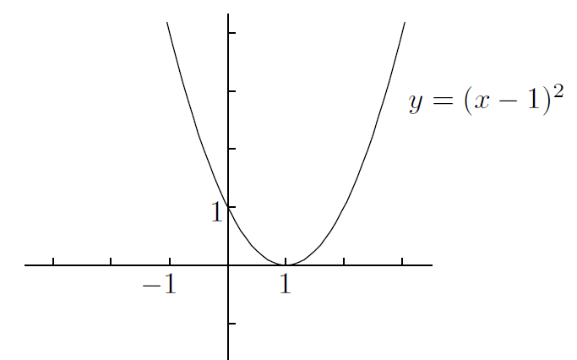

1.33

An even function: 

1.34

An odd function  of f.

1.35

Most functions are neither odd nor even

1.36

f(x) = 0

1.37

Knowing a function is ‘odd’ or ‘even’ interesting for plotting the graph, because: makes it quite easy to plot the function. If you can graph the right-side of function, the left-side is a piece of cake.

The graph of an even function has mirror symmetry about the y-axis. E.g.:

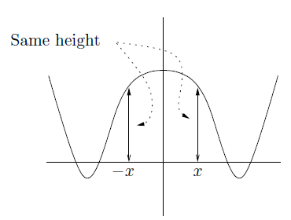

If a function is odd, it’s a mirror image but the opposite sign. E.g.:

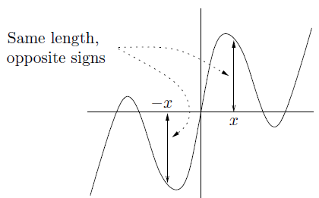

1.38

The product of 2 odd functions is always even.

The product of 2 even functions is always even.

The product of 1 even and 1 odd function is always odd.

1.39

The form of a linear function is this: 

It’s called a linear function because it’s a straight line.

1.40

You only need to know 2 points, to sketch the graph of a linear function. Just draw the straight line.

1.41

The“point-slope form of a linear function”:



1.42

If a line goes through (x1,y1) and (x2,y2), the slope is: 

1.43

A Polynomial is a function built out of Nonnegative integer powers of ‘x’

i.e. x, x squared, x cubed etc.

1.44

The degree of a polynomial is the highest power. i.e. with a non-zero coefficient.

1.45

Even, odd, even, odd……..

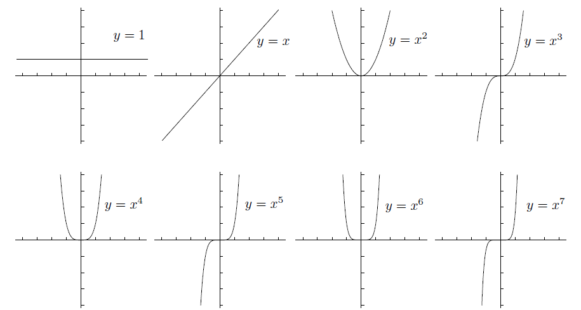

1.46

The leading coefficient of a polynomial is the coefficient of the term with the highest degree (highest power).

1.47

The leading coefficient and the degree of the polynomial impact the edges of the graph i.e. the direction of the extreme values.

There are 4 possibilities for what the edges of the graph can look like.

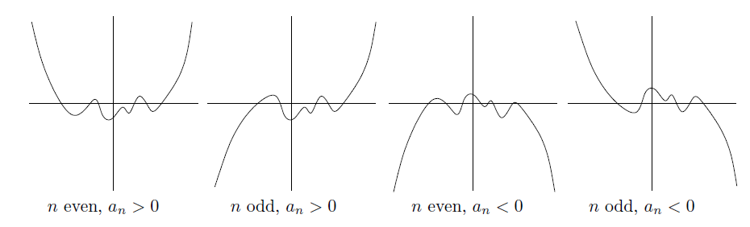

1.48

A quadratic equation is a polynomial whose largest power with a non-zero coefficient is 2. i.e. “degree 2 polynomials”

1.49

The discriminant 

1.50

Three possibilities for the discriminant:

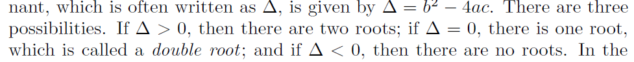

1.51

The root of the quadratic is calculated as follows:

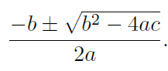

Note that the part in the square root is just the discriminant.

1.52

A monic quadratic is a quadratic with a leading coefficient of 1.

1.53

“completing the square” of a quadratic: 

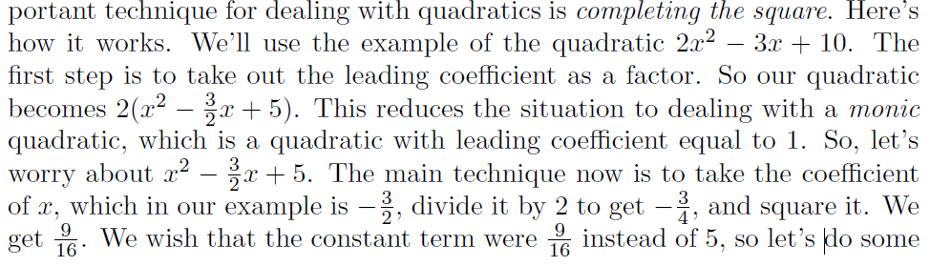

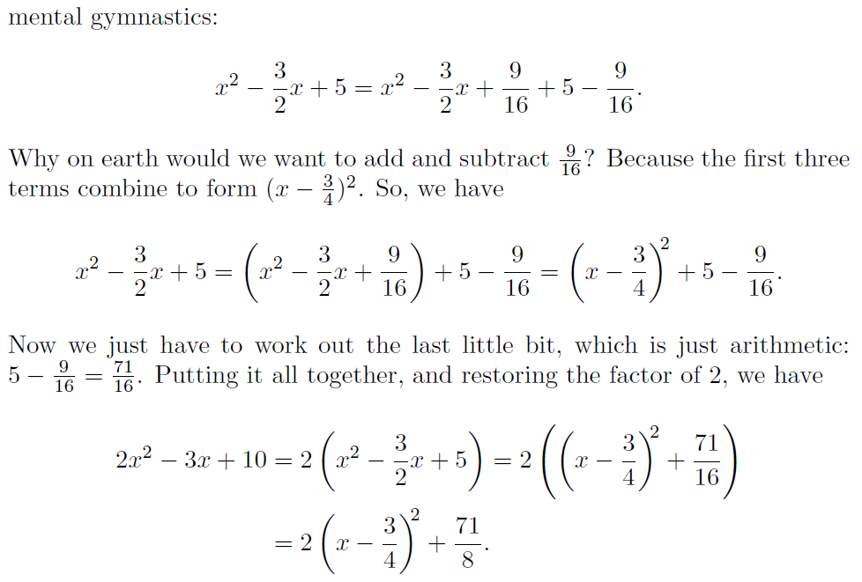

1.54

A rational function is one polynomial divided by another, i.e. of this form:

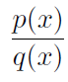

1.55

The simples examples of rational functions are polynomials themselves.

i.e. divided by the constant polynomial 1.

The next simplest are functions of the following form (where x is a positive integer):



1.56

For functions of the following form 

Where ‘n’ is 1, 2, 3, 4. The graphs look like this: (odd, even, odd, even) i.e. the odd powers look similar to each other, and the even powers look similar to each other.

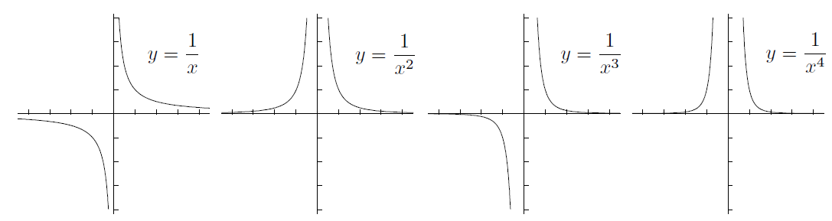

1.57

The graph of an exponential looks like this:

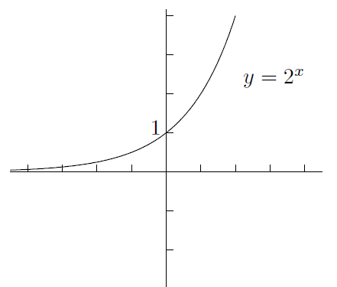

1.58

The graph of this: 

Looks similar to the graph of an exponential as shown above.

The ‘y-intercept’ is 1, the domain is the whole real line, the range is (0, infinity), and there is a horizontal asymptote on the left at y=0. It never touches the x-axis.

1.59

The graph of this 

Looks like:

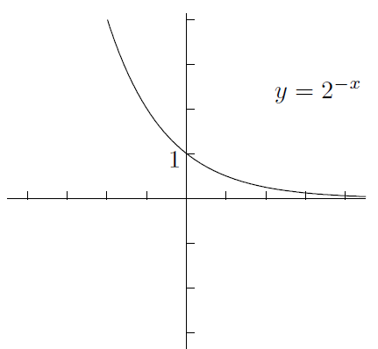

i.e. the reflection of 

1.61

The graph when the base is less than 1, e.g. 

This is the same as 

So it’s the same as the plot above.

Same for any value of b where: 0 < b < 1

1.62

The inverse function of  is the base 2 logarithm. i.e. 

This exists because it passed the horizontal line test.

1.63

The graph of  looks like: (i.e. no log exists for negative numbers, so there is a vertical asymptote at zero.) This is similar for logs of any base e.g. log10.

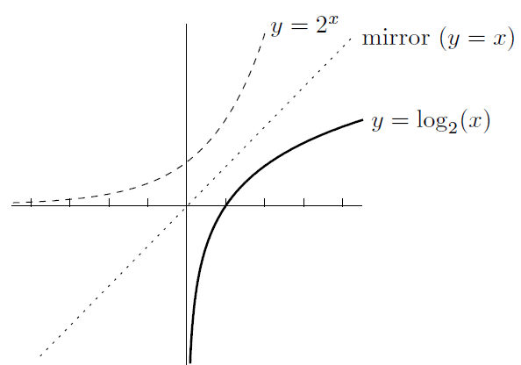

1.64

The absolute value function is written like this:



1.65

 is the distance between x and y on the number line.

1.66

The region of  is “the distance between x and 1 is less than or equal to 3”. i.e. all points that are no more than 3 units away from the number 1.

i.e. [-2,4]

1.67

To get the graph of the absolute value of a function, reflect everything that is below the x-axis, up above the x-axis.

1.68

The graph of  is this:

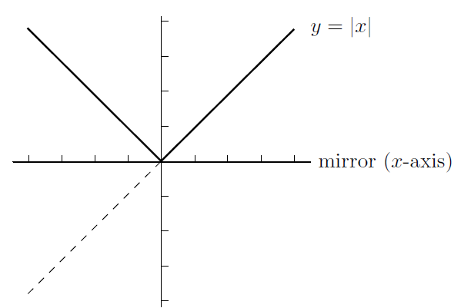

1.69

The graph of  looks like this:

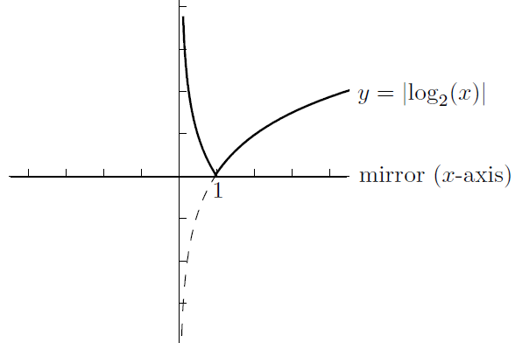

# Chapter 2 – Review of Trigonometry

# Chapter 3 – Introduction to Limits

# Chapter 4 – How To Solve Limit Problems Involving Polynomials

# Chapter 5 – Continuity and Differentiability

# Chapter 6 – How To Solve Differentiation Problems

# Chapter 7 – Trig Limits and Derivatives

# Chapter 8 – Implicit Differentiation and Related Rates

# Chapter 9 – Exponentials and Logarithms

# Chapter 10 – Inverse Functions and Inverse Trig Functions

# Chapter 11 – The Derivative and Graphs

# Chapter 12 – Sketching Graphs

# Chapter 13 – Optimisation and Linearisation

# Chapter 14 – L’Hopital’s Rule and Overview of Limits